# MESSAGE PROCESSOR & MESSAGE STORE

**Message Processor:**  A **message processor** is used to deliver messages that have been temporarily stored in a message store.

**Message Store:**  What is message store in WSO2?

A message store is **used to temporarily store messages before they are delivered to their destination by a message processor**. This approach is useful for serving traffic to back-end services that can only accept messages at a given rate, whereas incoming traffic to the ESB profile arrives at different rates.

Steps to create a message store and message processor.

Step 1: Create a new Maven Multi Module Project 🡪Create a ESB Layer🡪Create and API.

(Please refer the basic maven project creation for step 1)

Step 2: Go to the Enterprise Integrator in web browser and click on message store.

Step 3: Click on Add Message stores to create a new Message Store.

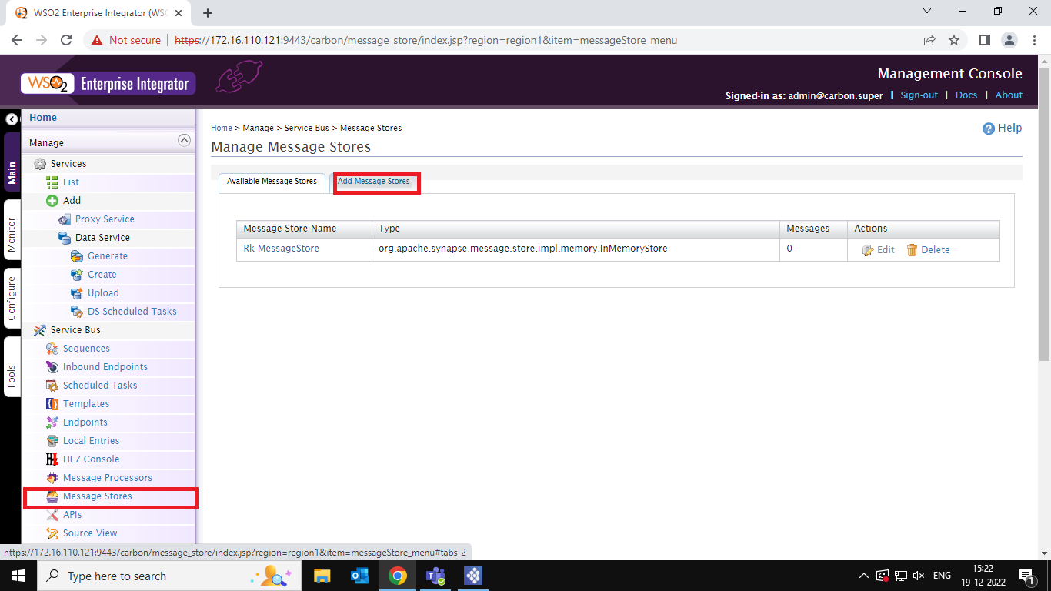

Step 4: Click on Add in memory message store to add a new message store.

Step 5: Give a name to the message store and then click on save.

If successfully created a message store It is visible in the Available Message Store like this.

Step 6: Click on Message Processor and then click on Add Message Processor and then click on Add Message Sampling Processor to Create a new Message processor.

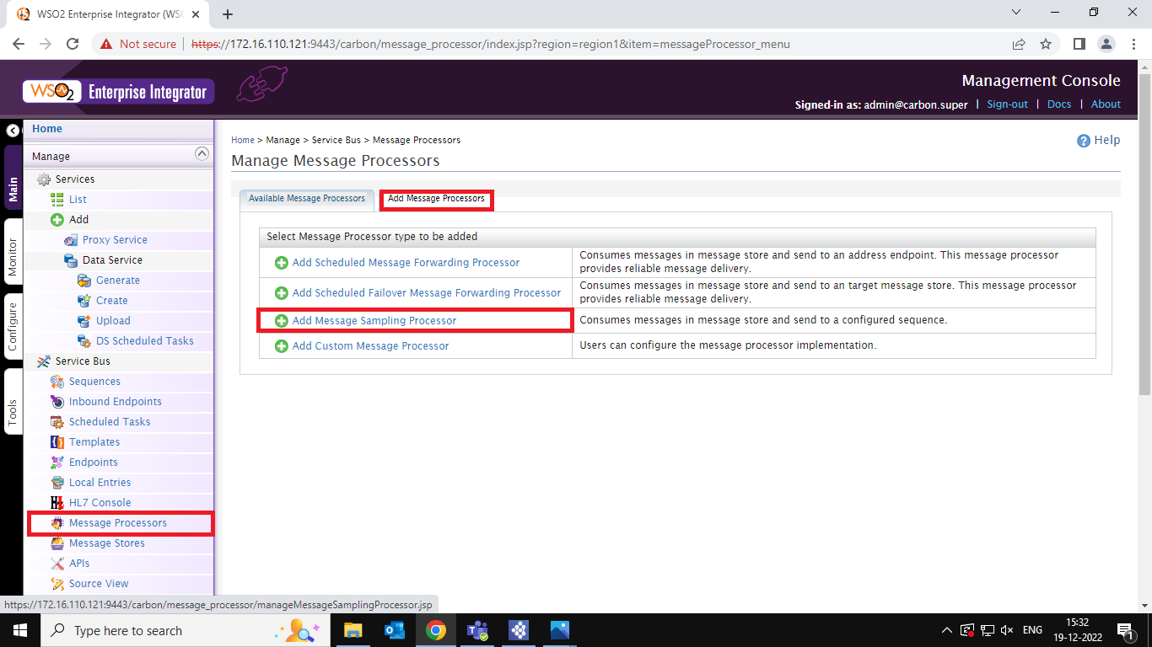

Step 7: Give a name to the Message Processor and give a name to the sequence 🡪Select a Message Store to store your messages.

If You Successfully created a new Message processor it is visible in the Available Message Processors.

Step 8: Now go to Integration Studio click on resources and change the method to post.🡪 and Select a log mediator drag and drop on the in sequence in the API.

Step 9: Click on the Log mediator and configure it by Log Level =CUSTOM.

Step 10: Click on ‘+’ Properties to add a new Element.

Step 11: Give a name to the property 🡪 property value = Literal 🡪property value =”Give A Message ”(The Value Can Be any that we can view in the console when the action is performed.) 🡪 Click on Finish.

Step 12: Select the Store Mediator drag and drop after the Log Mediator.

Step 13: Give a name to the as Our Message Store.

Step 14: Take another Log Mediator and configure it by Log Level =CUSTOM.

🡪: Click on ‘+’ Properties to add a new Element.

Step 15: Configure the Log Property as mentioned in the step no 11.

Step 16: Add to Respond Mediator. (Now the API Configuration is completed.)

Step 17: We must give a new sequence to it. Click in the sequence folder in the project explorer🡪New🡪Sequence.

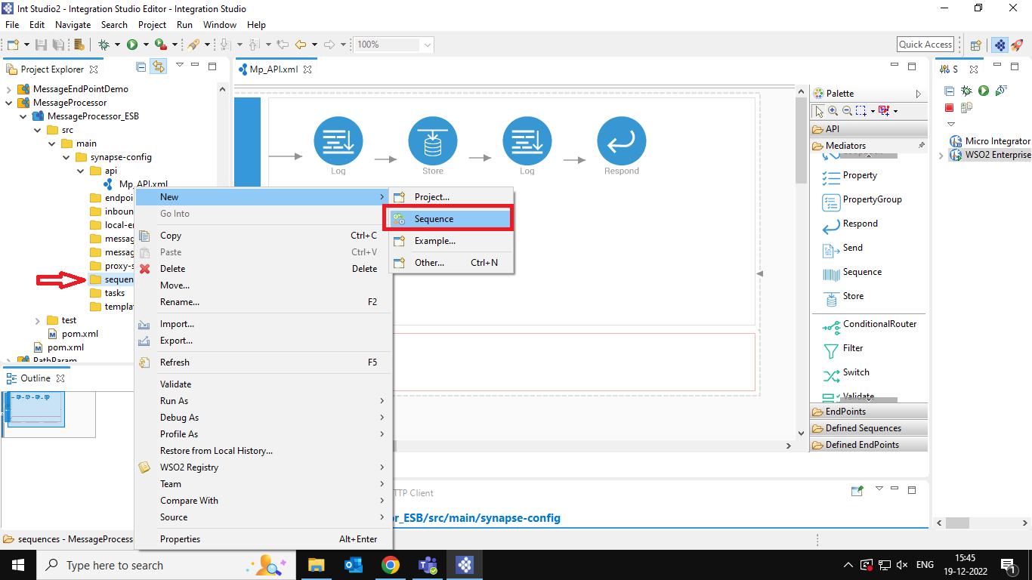

Step 18: Give a sequence name 🡪Click on Finish.

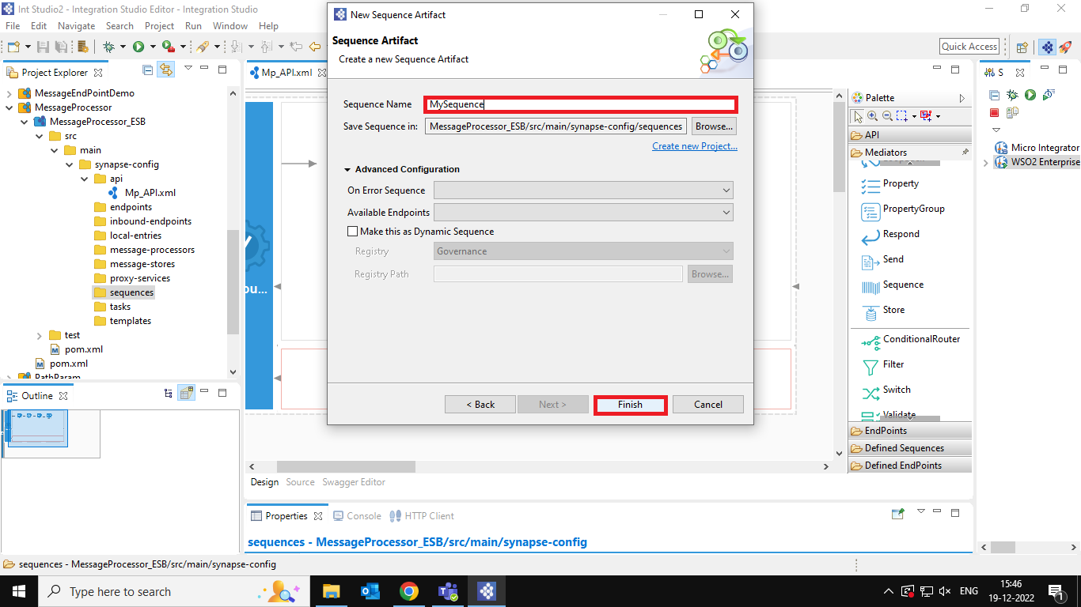

The UI For the Sequence Look Like the below picture.

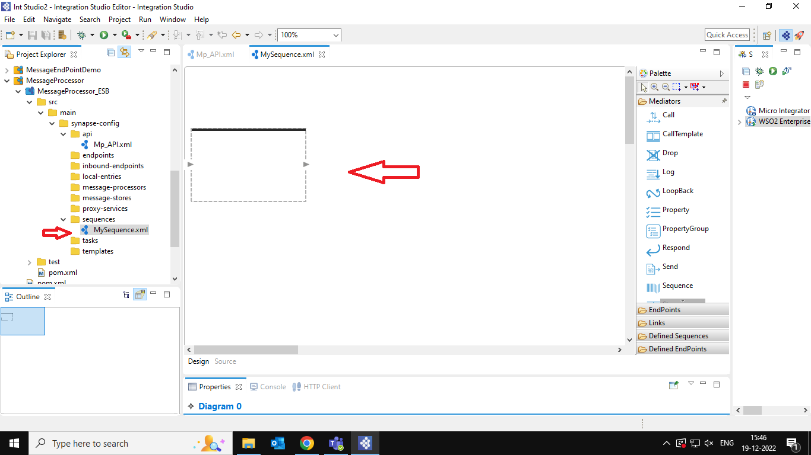

Step 19: Drag and drop the log mediator and configure it.

Step 20: Click on the Log mediator and configure it by Log Level =CUSTOM. 🡪 Click on ‘+’ Properties to add a new Element.

Step 21: Select the expression on the Expression Selector.

Step 22: Give the value of the Expression as $body.

Make Sure your Log Properties look like below and then click on finish.

Step 23: Drag and drop the Drop Mediator next to the log Mediator.

Step 24: Now create a CAR file and add the dependencies.

Step 25: Go to the WSO2 Enterprise Integrator and click on the message processors.

🡪Deactivate the Message Processor.

Step 26: Click on Yes to Deactivate your Message Processor.

Now Your Message Processor look a like this.

Step 27: Go to the API and copy the path and paste in the post man URL.

Step 28: Change the Method to Post and hit the Send button.

Step 29: Go to the Message Stores 🡪Available Message Stores 🡪Edit.

Step 30: Click on Show Envelope.

Now You Can See the Message you send, and it is added in the message.

You Can Also view your console as Message received and posted to queue.

